# SMART HOME AUTOMATION

REQUIREMENTS:

Arduino UNO R3,Temperature sensor(TMP36),LED, Resistor, Gas sensor, Breadboard Small, Piezo , Power supply.

SOFTWARE REQUIRED: Tinkercad Software

CODE:

float temp;

float vout;

float vout1;

int LED=13;

int gasSensor;

int piezo=7;

void setup()

{

pinMode(A0,INPUT);

pinMode(A1,INPUT);

pinMode(LED,OUTPUT);

pinMode(piezo,OUTPUT);

Serial.begin(9600);

}

void loop()

{

vout=analogRead(A1);

vout1=(vout/1023)*5000;

temp=(vout1-500)/10;

gasSensor=analogRead(A0);

if (temp>=80)

{

digitalWrite(LED,HIGH);

}

else

{

digitalWrite(LED,LOW);

}

if(gasSensor>=100)

{

digitalWrite(piezo,HIGH);

}

else

{

digitalWrite(piezo,LOW);

}

Serial.print("in DegreeC= ");

Serial.print(" ");

Serial.print(temp);

Serial.print("\t");

Serial.print("GasSensor= ");

Serial.print(" ");

Serial.print(gasSensor);

Serial.println();

delay(1000);

}

CIRCUIT DIAGRAM:

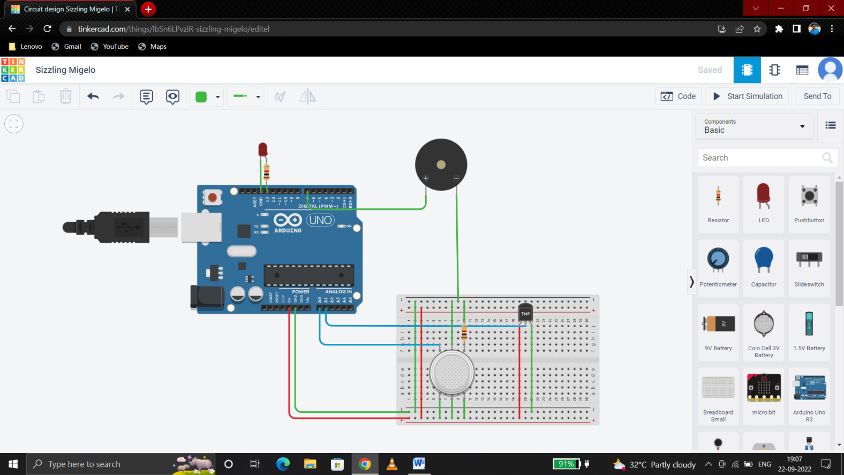

SCHEMATIC DIAGRAM:

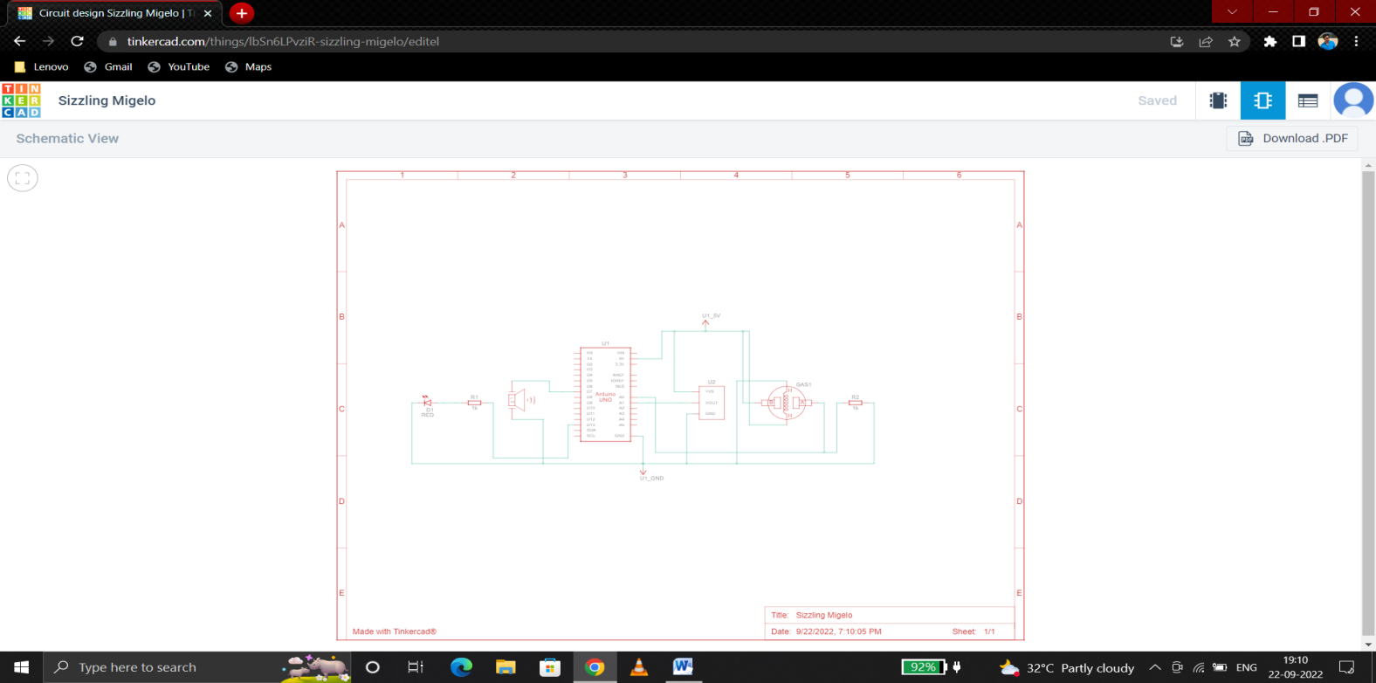

DEMO LINK:

<https://www.tinkercad.com/things/lbSn6LPvziR-sizzling-migelo/editel>